**3A DISTRICT 9 TRACK & FIELD MEET EAST BAY HIGH SCHOOL 4/19/2025**

**DIRECTIONS FOR TEAM BUSSES/VANS:**

From the North: Take I-75 South to exit 246 Apollo Beach Big Bend Rd. Exit west. School will be on your right. Turn right at the 1st light into the old bus depot behind Eisenhower Middle School. That area is reserved for team buses and coaches parking.

From the South: Take I-75 North to exit 246 Apollo Beach Big Bend Rd. Exit west, take a left at the light to head west on Big Bend Rd. At the 2nd light, take a right into the old bus depot behind Eisenhower Middle School. That area is reserved for team buses and coaches parking.

**Parking FOR SPECTATORS:**

~$3 for parking~

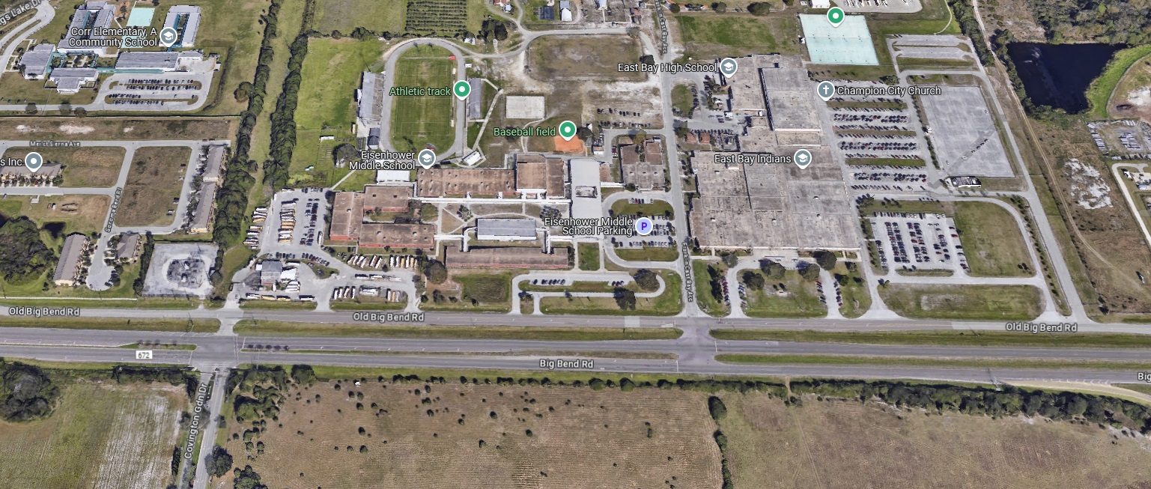

East Bay HS

**Spectator Parking**

Coming from 75

**Team Buses/ Drop-Off**

**Tickets**: Tickets can be purchased on GoFan for $8, no cash will be accepted.

**Team Assignments**:

|  |  |  |  |
| --- | --- | --- | --- |
| **School** | **Assignment 1** | **Assignment 2** | **Assignment 3** |
| East Bay | Staging | Hurdles |  |
| Blake | Girls Long/Triple |  |  |
| Braden River | Clerk |  |  |
| Brandon | B/G Shot |  |  |
| Freedom | B/G Discus | Exchange |  |
| Hillsborough | Boys Long/Triple | Exchange |  |
| Jesuit | B/G Pole Vault | Exchange |  |
| Leto | B/G Long & Triple |  |  |
| Middleton | B/G Javelin |  |  |
| Southeast | B/G Shot |  |  |
| Spoto | B/G High Jump | Exchange |  |

**Jury of Appeals:** Leto (Pizzo), Hillsborough (Triana), Braden River (Minihan), Spoto (Reyes), Jesuit (Wood)

**Notes:**

* There will be a trainer available near the finish line
* Water stations will be available around the field events and at the finish line
* Coaches will have wristbands and only those with wristbands will be allowed in coaches boxes
* There will be concessions. It will open around 9:00am
* Tent City will be in the far southwest side of the campus
* Warmup area will be behind the home stands once discus and javelin are completed
* The check-in tent will be in between the home stands and the field house. Athletes should check-in *race ready*.
* If an athlete needs to check-out of an event, they MUST check back in as soon as possible to avoid being scratched/disqualified
* After the throws are finished, only coaches and athletes will be allowed on the home side of the track.
* There will be a hospitality house for coaches and volunteers in the visitors’ concession stand, only those with wristbands will be admitted.
* If you are working an event, please bring a tape measure. Pokers will be provided.

**ORDER OF EVENTS**

**9:00AM:** Team Arrival

**9:30AM:** Coaches Meeting (packet pick-up)

**10:00AM:** FIELD EVENTS

Boy’s & Girl’s Long Jump (4 attempts)

Girl’s Pole Vault followed by Boy’s (3 attempts per height)

Girl’s High Jump followed by Boy’s (3 attempts per height)

Boy’s Javelin followed by Girl’s (4 attempts)

Girl’s Discus followed by Boy’s (4 attempts)

**11:00AM:** 4x800 – 2nd Round of Field Events

Boy’s & Girl’s Triple Jump (4 attempts)

Girl’s Shot followed by Boy’s (4 attempts)

**1:00pm** ROLLING FINALS

At least 30 minutes after the last field event, but no earlier than 1:00pm

100m HH

110m HH

100m

1600m

4x100m

400m

400m IH

800m

200m

3200m

4x400m

**Facility Layout**

**Concessions**

Timer

**Trainer**

**Javelin**

**Discus**

Visitor’s Stands

High Jump

**Long**

**Athlete Exit**

Check-in

Spectator entrance

Pole Vault

To buses

**Tent City**

This will be the warmup area once disc & jav are finished

Shot